NAME :T .Nandini

Roll no: 2025MCA16099

Project: Online Education Analytics Dashboard: Student Performance, Engagement & Dropout Analysis

University: Sri Padmavati Mahila visvavidyalayalam,tirupati

Final Project Report
Online Education Analytics Dashboard: Student Performance, Engagement & Dropout Analysis

Contents
- Introduction
  - Project Overview
  - Objectives
- Project Initialization and Planning Phase
  - Define Problem Statement
  - Project Proposal (Proposed Solution)
  - Initial Project Planning
- Data Collection and Preprocessing Phase
  - Data Collection Plan and Raw Data Sources Identified
  - Data Quality Report
  - Data Exploration and Preprocessing
- Data Visualization
  - Framing Business Questions
  - Developing Visualizations
- Dashboard
  - Dashboard Design Screenshot with Insights
- Report
  - Report Design Screenshot with Insights
- Performance Testing
  - Utilization of Data Filters
  - No. of Calculation Columns/Measures
  - No. of Visualizations
- Conclusion/Observation
- Future Scope
- Appendix
  - Source Code
  - GitHub & Project Demo Link

Introduction

Project Overview
Online education platforms record large amounts of student data, such as clicks, scores, demographics and final results. This project analyses an online education dataset of 32,593 records and 14 columns to understand how students perform, how engaged they are and why some drop out. The data was stored and queried in MySQL, and the results are presented as an interactive Power BI dashboard and report with KPIs, filters and drill-down visuals.

Objectives
    - Measure key indicators: total students, average score, average clicks, pass rate and dropout rate.
    - Study how engagement level and performance level relate to scores, results and dropout.
    - Compare students by region, gender and highest education.
    - Identify students at High and Very High risk so that support can be given early.
    - Deliver an easy-to-use dashboard that decision-makers can filter and explore.

Project Initialization and Planning Phase

Define Problem Statement
Online learning providers collect student data, but in raw tables it is hard to see who is engaged, who is struggling and who is likely to drop out. About one in four students (26%) drops out and only about half (52%) pass, yet there is no single view that shows how engagement, prior education, region and gender relate to these outcomes. Solving this helps instructors spot at-risk students early, target support and improve course design.

Project Proposal (Proposed Solution)
Approach: load the dataset into MySQL, analyse it with SQL queries, connect Power BI to the MySQL table, create KPI measures and build dashboard and report pages.
Key features: five KPI cards, six slicers, engagement, performance and risk analysis, dropout and pass rate by education, decomposition-tree drill-down and a Q&A visual.
Resources: standard laptop (8 GB RAM), MySQL Workbench and Power BI Desktop.

Initial Project Planning
The work was planned as 15 user stories (31 story points) over four sprints.

Sprint | Epics / Work | User Stories | Story Points
Sprint-1 | Data Loading, SQL Analysis (baseline KPIs and segments) | USN-1 to USN-4 | 7
Sprint-2 | Dropout analysis in SQL, Data Connection and KPIs, Dashboard Overview with slicers | USN-5 to USN-9 | 11
Sprint-3 | Engagement and Performance Analysis, Risk and Dropout Analysis, drill-down, Q&A | USN-10 to USN-13 | 9
Sprint-4 | Validation and Reporting | USN-14, USN-15 | 4
Total |  | 15 | 31

Data Collection and Preprocessing Phase

Data Collection Plan and Raw Data Sources Identified
The online education dataset was received as a CSV file and imported into the MySQL table online_education_dataset (database online_education_db) using MySQL Workbench. The import took about 22 seconds. Power BI reads the table through the MySQL connector.

Item | Details
Source / format | Online education student dataset, CSV
Size | 32,593 rows, 14 columns
Storage | MySQL table online_education_dataset
Tools | MySQL Workbench (SQL), Power BI Desktop (dashboard and report)

Key columns used in the analysis:

Column | Description
id_student | Unique student ID
Gender | Student gender (Male / Female)
Region | Region of the student (13 regions)
highest_education | Highest education level (No Formal quals, Lower Than A Level, A Level or Equivalent, HE Qualification, Post Graduate Qualification)
studied_credits | Credits studied by the student
total_clicks | Total clicks on the learning platform (engagement measure)
avg_score | Average assessment score
final_result | Final outcome: Pass, Distinction, Fail or Withdrawn
engagement_level | Engagement group: High, Medium or Low
performance_level | Performance group: High, Medium or Low
risk_level | Risk group: Very High Risk, High Risk, Low Risk or Safe
pass_flag | 1 if the student passed, otherwise 0
dropout_flag | 1 if the student dropped out, otherwise 0

Data Quality Report

Check | Result
Data load | CSV imported into MySQL without errors (all Action Output steps returned OK)
Raw records | 32,593 rows and 14 columns loaded
Records analysed | About 29.7K records in the Power BI dataset (7.64K dropout and 22.1K non-dropout, dropout_flag)
Unique students | 26,073 students (distinct id_student), so some students have more than one record; student totals use distinct counts
Category values | Consistent labels: engagement and performance (High, Medium, Low), risk (4 levels), final result (4 values), flags (0 or 1)
Row-count check | Record counts compared before and after cleaning (total_old and total_clean queries in MySQL Workbench)

Data Exploration and Preprocessing
    - Preview: SELECT query on the first 1,000 rows to check columns and values.
    - Cleaning check: row counts compared before and after cleaning; unique students counted with COUNT(DISTINCT id_student).
    - SQL exploration: 13 aggregate queries for totals, averages, pass and dropout counts, and breakdowns by engagement, performance, risk, click band, region and highest education (see Appendix 10.1).
    - Click bands: total clicks grouped into 0-500, 500-1000, 1000-2000, 2000-3000 and 3000+ to compare average scores.
    - Power BI preparation: connected the MySQL table and created five measures (Total Students, Dropout Rate, Average Score, Average Clicks, Pass Rate).

Data Visualization

Framing Business Questions
- How many students are enrolled, and what are the average score, average clicks, pass rate and dropout rate?
- How are students spread across engagement, performance and risk levels?
- Do students with higher engagement (more clicks) score higher?
- Which engagement and performance groups have the highest dropout?
- How do region and gender affect scores and final results?
- How does highest education influence dropout rate and pass rate?
- What share of students is at High or Very High risk?
- What are the final results (Pass, Distinction, Fail, Withdrawn)?

Developing Visualizations
The report has five pages and uses the visuals below.

Visualization | Chart Type | Purpose
KPI cards: Total Students, Dropout Rate, Average Score, Average Clicks, Pass Rate | Card | Headline metrics at a glance
Total Students by region; Average Score by region | Column chart | Compare enrolment and scores across 13 regions
Total Students by final_result | Donut / column chart | Share of Pass, Withdrawn, Fail and Distinction
Average and total clicks by engagement_level | Column chart | Link engagement to platform activity
Average Score by engagement_level and by performance_level | Column chart | Score gap between groups
Total Students by engagement_level | Pie chart | Engagement split
Dropout Rate and Pass Rate by highest_education | Column chart | Prior education versus outcomes
Total Students by risk_level | Pie chart | Risk distribution
Total Students by gender and final_result | 100% stacked bar | Gender comparison of results
Dropout split; clicks by engagement and final result; score by region and final result | Pie / 100% stacked charts | Dropout share and outcome patterns
Decomposition trees (2) | Decomposition tree | Drill down by risk, education, gender, region, engagement and result
Slicers (6) and Q&A | Slicer / Q&A | Filtering and plain-language questions

Dashboard

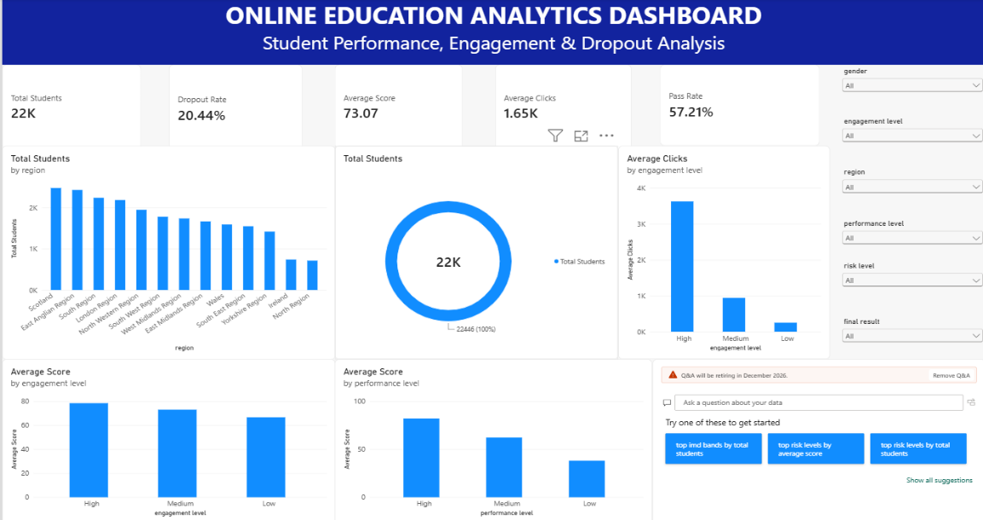

Dashboard Design Screenshot with Insights

Figure 1: Online Education Analytics Dashboard

Insights:
    - The dashboard covers about 22K students with an average score of 73.07, average clicks of 1.65K, a pass rate of 57.21 and a dropout rate of 020.44%.
    - Student numbers range from about 2.7K in the largest regions (Scotland, East Anglian) to about 1.0K in Ireland.
    - Final results: Pass 42.37%, Withdrawn 24.15%, Fail 23.13%, Distinction 10.35%.
    - High engagement students average about 3.7K clicks against 0.2K for Low, and average score rises from Low to High for both engagement and performance groups.
    - Six slicers filter every visual, and the Q&A visual answers questions in plain language.

Report

Report Design Screenshot with Insights

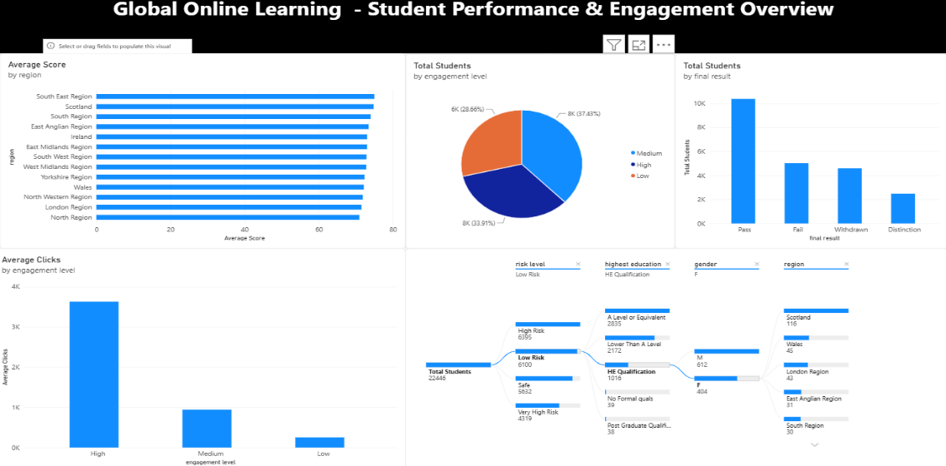

Figure 2: Student Performance & Engagement Overview page

Insights:
    - Students are split almost evenly by engagement: Low 35.32%, Medium 33.56%, High 31.12%.
    - Average score is very similar across regions (roughly 71 to 75), so region affects enrolment more than results.
    - High engagement students generate most of the total clicks.
    - The decomposition tree splits the 26,073 students by risk level: Very High Risk 6,952, High Risk 6,705, Low Risk 6,395, Safe 6,021.

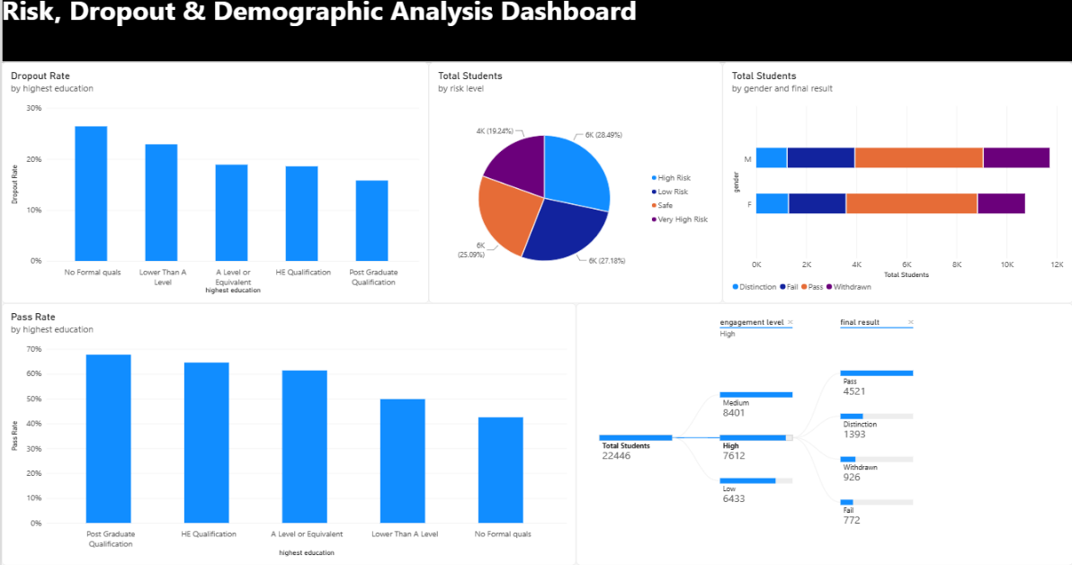
Figure 3: Risk, Dropout & Demographic Analysis page

Insights:
    - Dropout rate falls as education rises: 0.373 (No Formal quals) to 0.219 (Post Graduate). Pass rate shows the opposite trend, from about 0.34 to about 0.67.
    - Risk levels are spread evenly (Very High 26.66%, High 25.72%, Low 24.53%, Safe 23.09%), so 52.38% of students are High or Very High risk.
    - Female students pass more often (44.40% vs 40.70%) and withdraw less (22.18% vs 25.78%) than male students.
    - Engagement level counts: Low 9,209, Medium 8,750, High 8,114 students.

Performance Testing

Test | Count | Details
7.1 Utilization of Data Filters | 6 slicers | gender, region, engagement_level, performance_level, risk_level and final_result (dropdown slicers on the Dashboard page)
7.2 No. of Calculation Columns/Measures | 5 measures | Total Students, Dropout Rate, Average Score, Average Clicks, Pass Rate. Engagement, performance and risk levels come directly from the dataset.
7.3 No. of Visualizations | 40 visuals | 34 charts, KPI cards, decomposition trees and Q&A, plus 6 slicers, across 5 report pages

Conclusion/Observation
- The platform has about 26K students; 26% drop out and about 52% pass, with an average score of 72.84.
- Engagement matters: High engagement students record far more clicks (about 3.7K vs 0.2K) and higher scores than Low engagement students.
- Prior education matters: dropout is highest for students with no formal qualifications (0.373) and lowest for postgraduates (0.219).
- Region changes how many students enrol but has little effect on average score.

- Over half (52.38%) of students are at High or Very High risk and should be the first group to receive support.
- Female students have a higher pass share and a lower withdrawal share than male students.
- Recommendation: monitor low-click students early, give extra support to students with lower prior education, and track the High and Very High risk groups.

Future Scope
- Build a machine-learning model to predict dropout and risk before results are known.
- Add time-based data (weekly clicks, assessment dates) to study trends and seasonality.
- Publish the report to Power BI Service with scheduled refresh and role-based access.
- Add course and assessment-level data to see which courses have the highest dropout.
- Set up automatic alerts for instructors when a student’s engagement drops.

Appendix

Source Code
SQL queries used for the analysis (MySQL):
use online_education_db;

-- 1. Total students
SELECT COUNT(DISTINCT id_student) AS total_students FROM online_education_dataset;

-- 2. Average student score
SELECT ROUND(AVG(avg_score), 2) AS average_student_score FROM online_education_dataset;

-- 3. Average total clicks
SELECT ROUND(AVG(total_clicks), 2) AS average_total_clicks FROM online_education_dataset;

-- 4. Students passed and dropped out
SELECT SUM(CASE WHEN pass_flag = 1 THEN 1 ELSE 0 END) AS students_passed, SUM(CASE WHEN dropout_flag = 1 THEN 1 ELSE 0 END) AS students_dropped_out
FROM online_education_dataset;

-- 5. Students by engagement level SELECT engagement_level,
COUNT(DISTINCT id_student) AS total_students FROM online_education_dataset
GROUP BY engagement_level ORDER BY total_students DESC;

-- 6. Students and average score by performance level SELECT performance_level,
COUNT(DISTINCT id_student) AS total_students, ROUND(AVG(avg_score), 2) AS average_score
FROM online_education_dataset GROUP BY performance_level ORDER BY average_score DESC;

-- 7. Students by risk level SELECT risk_level,
COUNT(DISTINCT id_student) AS total_students FROM online_education_dataset
GROUP BY risk_level
ORDER BY total_students DESC;

-- 8. Average score by engagement level SELECT engagement_level,
ROUND(AVG(avg_score), 2) AS average_score, COUNT(DISTINCT id_student) AS total_students
FROM online_education_dataset GROUP BY engagement_level ORDER BY average_score DESC;

-- 9. Average score by click band SELECT CASE
WHEN total_clicks < 500 THEN '0 - 500'
WHEN total_clicks < 1000 THEN '500 - 1000'
WHEN total_clicks < 2000 THEN '1000 - 2000'
WHEN total_clicks < 3000 THEN '2000 - 3000'
ELSE '3000+'
END AS click_band,
COUNT(DISTINCT id_student) AS total_students, ROUND(AVG(avg_score), 2) AS average_score
FROM online_education_dataset GROUP BY click_band
ORDER BY average_score DESC;

-- 10. Dropout rate by engagement level SELECT engagement_level,
COUNT(DISTINCT id_student) AS total_students,

SUM(CASE WHEN dropout_flag = 1 THEN 1 ELSE 0 END) AS dropout_students,
ROUND(100.0 * SUM(CASE WHEN dropout_flag = 1 THEN 1 ELSE 0 END) / COUNT(*), 2) AS
dropout_rate
FROM online_education_dataset GROUP BY engagement_level ORDER BY dropout_rate DESC;

-- 11. Dropout rate by performance level SELECT performance_level,
COUNT(DISTINCT id_student) AS total_students,
SUM(CASE WHEN dropout_flag = 1 THEN 1 ELSE 0 END) AS dropout_students,
ROUND(100.0 * SUM(CASE WHEN dropout_flag = 1 THEN 1 ELSE 0 END) / COUNT(*), 2) AS
dropout_rate
FROM online_education_dataset GROUP BY performance_level ORDER BY dropout_rate DESC;

-- 12. Students, score and clicks by region SELECT region,
COUNT(DISTINCT id_student) AS total_students, ROUND(AVG(avg_score), 2) AS average_score, ROUND(AVG(total_clicks), 2) AS average_clicks
FROM online_education_dataset GROUP BY region
ORDER BY total_students DESC;

-- 13. Students, score and clicks by highest education SELECT highest_education,
COUNT(DISTINCT id_student) AS total_students, ROUND(AVG(avg_score), 2) AS average_score, ROUND(AVG(total_clicks), 2) AS average_clicks
FROM online_education_dataset GROUP BY highest_education ORDER BY average_score DESC;

  - GitHub & Project Demo Link GitHub repository: https://github.com/nandininandu67/-Online-Education-Analytics-Dashboard-Student-Performance-Engagement-Dropout-Analysis

